1St Annual
Home Run Derby

Wear Blue April 24th, 2020 SIGN-IN STARTS

Wear Blue for Join us Riverside Ball Field 6:30-7:30 PM
Child Abuse Awareness Month Registration Fee: $10 Derby starts at 7:30 PM
Sneakers, Shirt, Ball Cap, etc See you at Riverside Ball Field
General Registration:
Paid Y/N
Batter’s Name (please print):____________________________________________________
Age if under 18________ * Must have parental/Guardian signature below
Address:____________________________________________________________________________
Phone: ____________________________ Email:______________________________________
In consideration of my entry in the Home Run Derby and Cow Pie Bingo fundraiser, I, for myself, my heirs, my executors and administrators, wave and release any and all rights and cares for damages I have or may hereafter have against the organizers of this event, its principles, its employees, all sponsors, property owners of land located on and around Riverside Ball Park and Riverside Park in Yankton, SD, and their representatives and all claims of damages, demands, actions, whatsoever in any manner as a result of my participation in the Home Run Derby event, including travel to and from the event. I attest and verify that I am physically fit and have sufficiently trained for completion of this event and I have not been advised otherwise by a qualified medical person. Further, I hereby grant full permission to any and all of the foregoing to use my name and likeness in any broadcast, telecast, video, or print media of the event without compensation.
Signature:________________________________________ Date:____________________________________________
Adult signature for Child under 18: _____________________________________________________________
Printed Name:___________________________________
Please return this form to River City Domestic Violence Center before or on
Friday, April 24th
*Please make checks payable to River City Family Connections
Thank you for participating in and taking a “stand” against child abuse!
If you have any other questions regarding The Home Run Derby and Cow Pie Bingo, please contact River City Family Connections at PO Box 626, Yankton, SD, 57078, 605-665-1204
PLEASE JOIN US
Friday, April 24th
At
Riverside Ball Park

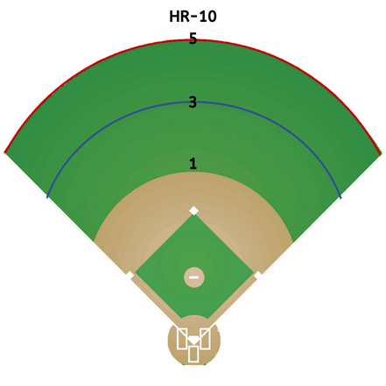
Home Run Derby Rules

-10 outs per hitter with an out being any swing that doesn't result in a home run
-Winners will be decided based on points

Point System

1 point for a ball hit out of the infield on the fly
3 points for a ball hit over the temporary fence
5 points for a ball hit to the warning track or off the outer fence
10 points for a home run
Double points Money Ball for the last out (if a home run is hit on the last out, another money ball will be given)
Office Use Only:
Paid: Y N
Staff:_____

